IRONY

Irony is the use of words to convey a meaning that is the opposite of its literal meaning. It is a technique of indicating, as through character or plot development, an intention or attitude opposite to that which is actually or ostensibly stated.
Irony is a manner of organizing a work so as to give full expression to contradictory or complementary impulses, attitudes, etc., especially as a means of indicating detachment from a subject, theme, or emotion.
The essential feature of irony is the indirect presentation of a contradiction between an action or expression and the context in which it occurs. In the figure of speech, emphasis is placed on the pposition between the literal and intended meaning of a statement. One thing is said and its opposite is implied, as in the comment, “Beautiful weather, isn't it?” made when it is raining or nasty. Ironic literature exploits, in addition to the rhetorical figure, such devices as character development, situation, and plot to stress the paradoxical nature of reality or the contrast between an ideal and actual condition, set of circumstances, etc., frequently in such a way as to stress the absurdity present in the contradiction between substance and form.

IRONY IN LITERATURE

Irony is a rhetorical device used in most of the modern fiction and literature in general. It
is widely used in psychological literary works, for example, in James Joyce’s fiction. Irony is a disagreement or incongruity between what is said and what is understood, or what is expected and what actually occurs. It can be used intentionally or can happen unintentionally. Audience’s role is very important. Authors can use irony to make their audience stop and think about what has just been said, or to emphasize a central idea. The audience's role in realizing the difference between what is said and what is normal or expected is essential to the successful use of irony.
Irony, in its broadest sense, is a rhetorical device, literary technique, or event characterized by an incongruity, or contrast, between reality (what is) and appearance (what seems to be). Verbal, dramatic, and situational irony are often used for emphasis in the assertion of a truth.

There are several types of irony in literature. Three main types are verbal irony, dramatic irony, and situational irony.
1. Verbal Irony: This is the contrast between what is said and what is meant; e.g. sarcasm.
2. Dramatic Irony: This is the contrast between what the character thinks to be true and what we (the reader) know to be true. Sometimes as we read we are placed in the position of knowing more than what one character knows. Because we know something the character does not, we read to discover how the character will react when he or she learns the truth of the situation.
3. Situational Irony: This is the most common in literature. It is the contrast between what happens and what was expected (or what would seem appropriate). Because it emerges from the events and circumstances of a story, it is often more subtle and effective than verbal or dramatic irony.

Irony is often an effective way for an author to express ideas of what she thinks describes the society in which she lives. Irony can explore the differences between what a society or person says or does and how they actually live. A society which claims to value truth and justice, but actually tolerates or encourages lying and injustice is ironic.

Irony can occur when the reader knows things in the story that the characters do not---for example, audiences are aware of the fact that Viola in William Shakespeare's Twelfth Night is actually a woman dressed as a man, even when other characters are not.

Irony is effective because it prevents the author's work from becoming didactic. Since most works of fiction that employ irony tend to deal with serious issues, such as the hypocrisy in religion, society, or government, a more serious or realistic approach risks becoming pretentious. Irony, particularly satire, can be an effective way to not only approach such topics but do so in way that is humorous or entertaining.

Another reason why irony is effective is because it allows readers to see the discrepancies the author is pointing out about humans or society. For instance, in Twelfth Night, audiences are able to witness the absurdities that Elizabethan society placed on decorum within courtship rituals and the ways those rituals are complicated by gender expectations. With irony, unlike most literary tropes, readers are let in on the joke. They see and know things of which the characters themselves are not aware. Thus, it gives them a sense of distance from the story. This allows them to parse the
ideas and themes that are being expressed in ways that are not always readily available in stories that do not employ the use of irony. Irony also allows readers to understand characters in ways that the characters don't know of themselves.

The beauty of works of literature is mainly due to the different types of figurative forms of speech that is used by many of the literary masters. Irony is one of the popular figurative forms of speeches. This is primarily because of its use in contemporary forms of literature, and even in performance arts. Since irony is commonly used in satires, many people would often equate the two together. It is true that the use of irony is a vital and integral component in satires. Irony and
satire are completely two different literary terms. Satire uses the technique of irony. But they are not exclusive to each other. Irony occurs not just in satire but in dramatic and comedic art as well. Likewise, satire also uses many other rhetorical and comedic techniques, such as ridicule, to accomplish its goal.

Satire is a form of comedic criticism and it uses the technique of Irony to humorously criticize something/someone. So irony is one of the chief instruments of satire.

ECHOIC MENTION APPROACH

A significant aspect of ironical utterances is that they often have some kind of ‘victim’ or ‘target,’ at whom the irony is directed. Picking out the victim of the irony plays a major role in interpreting the speaker’s meaning in ironical utterances. Relevance theorists explicitly refer to the victim of the irony: “The analysis of irony as a type of mention makes it possible to predict which ironical utterances will have a particular victim, and who that victim will be.” . The echoic
mention approach to irony provides an answer to the question of whom the speaker’s attitude is directed towards.
Irony only becomes totally elusive when one cannot identify the target in any terms
at all. In some of these utterances the originator is not specific, is vague or even imagined, and in some of them what is echoed are beliefs or opinions that go far back in time. Sometimes, the echoed beliefs are only implied.

3 Models of Communication

1. Code model of communication : The code model assumes that communication is the act of the speaker putting his or her intensions into words (encoding) and the hearer analyzing these words to reconstruct the speaker’s intensions from them (decoding).
2. Standard pragmatic model : The Standard Pragmatic Model assumes communication to be a more complex process than encoding and decoding. It assumes the speaker of that utterance to obey the
cooperative principle (stating that individuals in their objective to communicate
effectively agree to cooperate in the exchange of information) and subsequently the four
conversational maxims of Quality (say what is true and what you can prove), Quantity
(say no more and no less than necessary), Relation (make your contribution relevant) and
Manner (be clear and avoid ambiguity and obscurity) which derive from the cooperative
principle.
3. Relevance Theory : It follows the relevance principle, which states that speakers assume utterances to be relevant in their information and try to accommodate seemingly ‘irrelevant’ information by drawing inferences from contextual knowledge.

There is another kind of irony called Socratic irony.
Socratic irony is when a speaker in an argument pretends to be ignorant only to let his opponent contradict himself in his own arguments. The Socratic ironist only uses questions which ask the opponent to explain a point further, thereby forcing the opponent to go into more and more detail and ultimately to reveal inconsistency in the opponent’s argumentation. But Socratic irony also refers to the language of the con man that deceives people to believe him to be somebody he is not
and to know what he does not know. Socratic irony aims to deceive the addressee. It is also the inspiration for the Pretence Theory of irony in modern times.

Echoes are verbalized thoughts.
1. Literal echoes
2. Figurative echoes
Some of these figurative echoes are ironic echoes.

It is believed that in irony the literal meaning is overridden by the non-literal meaning. Instead, Giora claims that when the non-literal meaning is computed the literal meaning is not discarded but both are stored to mark the ironic contrast between what is literally said and what is non-literally intended. She emphasises that the literal meaning of an utterance is always computed first, in literal and non-literal language.

REFERENCES

1. Retrieved from <http://www.thefreedictionary.com/humour>
2. Retrieved from <http://oxforddictionaries.com/definition/english/humour>
3. Retrieved from <http://dictionary.reference.com/browse/irony>
4. Retrieved from <http://dictionary.reference.com/browse/satire>
5. Retrieved from <http://dictionary.reference.com/browse/irony>
6. Retrieved from <http://shrdocs.com/presentations/15505/index.html>
7. Retrieved from <http://en.wikipedia.org/wiki/Humour>
8. Retrieved from <https://www.ideals.illinois.edu/handle/2142/20195
9. Retrieved from <http://evankingston.com/humors-uses-in-literature/>
10. Retrieved from <http://udleditions.cast.org/craft_ld_irony.html>
11. Retrieved from <http://en.wikipedia.org/wiki/Irony>
12. Retrieved from <http://voices.yahoo.com/irony-literature-it-used-6386106.html?cat=2>
13. Retrieved from <http://literarydevices.net/satire/>
14. Retrieved from <http://www.questia.com/library/literature/literary-themes-and-topics/satire-in-literature>
15. Retrieved from <http://www.wisegeek.com/what-is-the-difference-between-satire-and-irony.htm>
16. Retrieved from <http://www.differencebetween.net/language/difference-between-irony-and-satire/>
17. Dews, S., J. Kaplan, and E. Winner. (1995). Why not say it directly? The social functions of irony, Discourse
Processes. v. 19. p. 348.
18. Giora, R. (1995). On irony and negation, Discourse Processes 19. pp. 256-257.
19. Ibid.
20. Raskin, V. (1985). Semantic Mechanisms of Humor. Dordrecht: D. Reidel.
21. Attardo, S. (1997). The semantic foundations of cognitive theories of humor, HUMOR: International Journal of
Humor Research. v. 10 (4). pp. 395-420.
22. Colston, H. (2000). “Dewey defeats Truman”: Interpreting ironic restatement, Journal of Language and Social
Psychology. v. 19 (1). p. 1563.
23. Toplak, M., and A. Katz. (2000). On the uses of sarcastic irony, Journal of Pragmatics. v. 32 (10). pp. 1467-1488.
24. Retrieved from <http://citeseerx.ist.psu.edu/viewdoc/download?doi=10.1.1.73.5506&rep=rep1&type=pdf>

ALGORITHM

The membership criterion for including a tweet in our corpus is that each should contain a specific hashtag (i.e. a tag provided by users when posting their tweets in order to tie their contribution to a particular subject). The hashtags selected are #irony, in which a tweet explicitly declares its ironic
nature, and #education, #humor, and #politics, to provide a large sample of potentially non-ironic tweets.

Based on these criteria, we collate an evaluation corpus of 40,000 tweets, which is divided into four parts, comprising one self-described positive set and three other sets that are not so tagged, and thus assumed to be negative. Each set contains 10,000 different tweets (though all tweets may not be textually unique). We assume therefore that our corpus contains 10,000 ironic tweets and 30,000 largely non-ironic tweets.

In order to estimate the overlap between the ironic set and each of the three non-ironic ones, the Monge Elkan distance was employed. This measure, according to Monge and Elkan (1996), allows for gaps of unmatched characters.

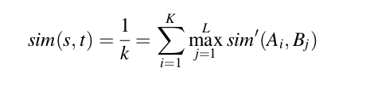

According to this formula, s and t are substrings s = a 1 , ..., a K and t = b, ..., b L ,
whereas sim 0 is the distance function.
The Monge Elkan distance approaches 1.0 as the data sets share more of their vocabulary. The results in Table 2 thus suggest a difference between the vocabularies of the four tweet sets. As one might expect, this difference is least pronounced between the irony and humor sets.

THE IRONY MODEL

We propose a model that is organized according to four types of conceptual feature:
signatures, unexpectedness, style, and emotional scenarios.

These dimensions are listed and discussed below: 5
1. Signatures: concerning pointedness, counter-factuality, and temporal compression;
2. Unexpectedness: concerning temporal imbalance and contextual imbalance;
3. Style: as captured by character-grams (c-grams), skip-grams (s-grams), and polarity skip-grams (ps-grams);
4. Emotional scenarios: concerning activation, imagery, and pleasantness.

Signatures

Pointedness is focused on explicit marks which, according to the most relevant properties of irony (cf. Sect. 2), should reflect a sharp distinction in the information that is transmitted. The set of elements considered here are punctuation marks (such as ., ..., ;, ?, !, :, ,), emoticons, 6 quotes, and capitalized words.
Counter-factuality is focused instead on implicit marks, i.e. discursive terms that hint at opposition or contradiction in a text, such as about, nevertheless, nonetheless and yet.
The last dimension, temporal compression, is focused on identifying elements related to opposition in time; i.e. terms that indicate an abrupt change in a narrative. These elements are
represented by a set of temporal adverbs such as suddenly, now, abruptly, and so on.

Unexpectedness

Temporal imbalance, is used to reflect the degree of opposition in a text with respect to the information profiled in the present and past tenses. Unlike the temporal compression dimension, here we are focused on analyzing divergences related to verbs only (e.g. ‘‘I hate that when you get a
girlfriend most of the girls that didn 0 t want you all of a sudden want you!).
Contextual imbalance, in contrast, is intended to capture inconsistencies within a context.

Style

c-grams, captures frequent sequences of morphological information, such as affixes and suffixes (e.g. -ly). In order to obtain the best c-grams sequences, we consider sequences of 3–5 characters.

In the second kind of sequences, s-grams, we widen the scope to consider whole
words. But instead of looking for sequences of adjacent words (simple n-grams), we
look for word sequences that contain (or skip over) arbitrary gaps; hence the name
skip-grams (cf. Guthrie et al. 2006; Chin-Yew and Och 2004). For instance, in the
sentence ‘‘There are far too many crazy people in my psychology class’’, a typical
2-gram is represented by the sequences there are, whereas a 2-sgram, with a 1 token
gap, would be there far. Gaps are limited to 2 or 3 word skips, because longer
sequences are not very common, especially if we take into account the length of the
micro-blogging texts in the evaluation corpus (tweets must contain no more than
140 characters; i.e. *12 words).

The last sequence type, polarity s-grams, provides sequences of abstract
categories based on s-grams; i.e. we can produce an abstract structure for a text
from sequences of positive and negative terms instead of specific content words or
characters. The intuition here is that one generally employs positive terms to
communicate a negative meaning when using irony; for example, there is usually a
positive ground in an ironic comparison that conveys a critical meaning (cf. Veale
and Hao 2009). As in the case of s-grams, the gaps in ps-grams are limited to 2-word
and 3-word skips only.

Emotional Scenarios

Activation refers to the degree of response, either passive or active, that
humans exhibit in an emotional state (e.g. burning is more active than basic).
Imagery quantifies how easy or difficult is to form a mental picture for a given word
(e.g. it is more difficult to mentally depict never than alcoholic).
Pleasantness quantifies the degree of pleasure suggested by a word.

EVALUATION

Phase 1

In the first phase, each one of the 40,000 tweets is converted into a vector of term
frequencies according to a representativeness criterion. This criterion is intended to
provide a global insight into the effectiveness of the model for actually identifying
patterns in the ways that users employ the four conceptual features when genuinely
speaking ironically. We need to know that the model is not simply detecting
artifacts of the ways that users employ the #irony hashtag, or worse, artifacts of the
way they use the #education, #humor, or #politics hashtags.

The representativeness of a given document d k (e.g. a tweet) is computed
separately for every dimension of each feature according to Formula

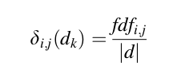

where i is the i-th feature (i = 1, ..., 4); j is the j-th dimension of i (j = 1, ..., 2 for
the unexpectedness feature, and 1, ..., 3 otherwise); fdf (feature dimension
frequency) is the frequency of the dimension j of the feature i; and |d| is the
length (in terms of tokens) of the k-th document d k .

To aid understanding our
guiding principle, let us take the signatures feature (i). We can compute the
representativeness of its three dimensions j (pointedness, counter-factuality, and
temporal compression) by applying Formula 2 in the following tweet: ‘‘HAHA-
HAHA!!! now thats the definition of !!! lol...tell him to kick rocks!’’
• concerning pointedness, d = 0.85 (HAHAHAHA, !!!, !!!, lol, ..., !) / (hahahaha,
now, definit, lol, tell, kick, rock);
• concerning counter-factuality, d = 0;
• concerning temporal-compression, d = 0.14 (now) / (hahahaha, now, definit, lol,
tell, kick, rock).

This process is applied to all dimensions for all four features.
Once d i,j is obtained for every single tweet d k , a representativeness threshold is
established in order to filter the documents that are more likely to have ironic
content. 10 In this respect, if d i,j (d k ) is C0.5, then document d k is assigned a
representativeness value of 1 (i.e. dimension j of feature i is representative of d k );
otherwise, a representativeness value of 0 (not representative at all) is assigned. For
instance, considering the previous example, only one dimension of the signatures
feature exceeds such threshold: counter-factuality (d = 0.85), thus it is considered as
representative; whereas pointedness and temporal-compression do not (d = 0 and
0.14, respectively), thus they are not considered as representative.

Lastly, in order to observe the representativeness of the model in terms of sets, an
overall representativeness score for each dimension j is calculated by summing
d i,j (d k ) for all documents in the set they belong to, and normalizing by the size of the
set (10,000).

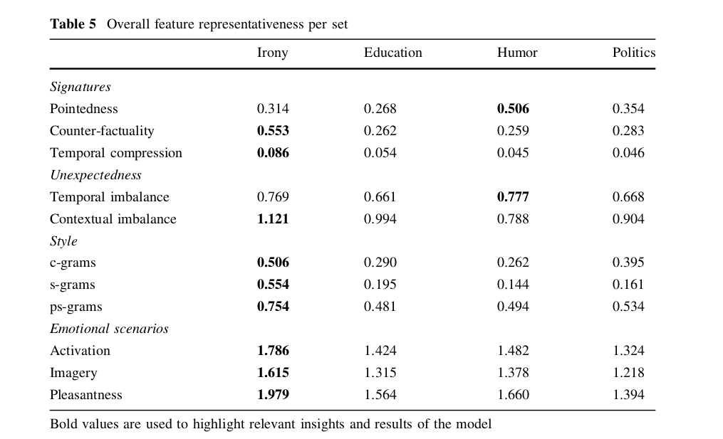

Based on the representativeness of these terms, their frequencies are stored in a vector. The following graph is then plotted based on the positive, negative and neutral terms used in the context.

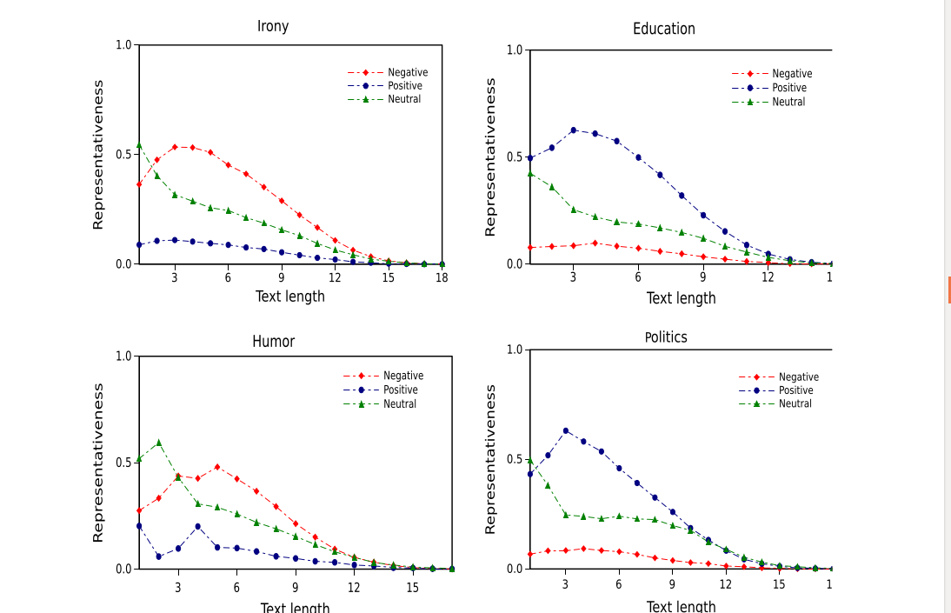

Phase 2

Classification of text is done here. Many classifiers are used for this purpose.
Two popular algorithms from the literature are used to perform
classification: the Naı ̈ve Bayes approach, and decision trees. 12 We choose these
particular algorithms for two reasons: first, we use the Naı ̈ve Bayes algorithm since
our experiments are focused on the presence or absence of features as represented
by boolean attributes (Witten and Frank 2005) that are treated as independent
variables, assigned to the class with maximum probability; and second, decision
trees are used in order to analyze the sequences of decisions regarding the relevance
of such features, and to be able to make further inferences about them.

Two distributional scenarios are evaluated: (1) a balanced
distribution, comprising 50 % positive texts and 50 % negative texts; (2) an imbalanced distribution, with a more realistic mix of 30 % ironic texts and 70 %
non-ironic texts.

The classifiers, both for balanced and imbalanced distributions, were tested using
tenfold cross validation. The model evidently improves its performance in almost all cases each time a new feature is added (e.g. the accuracy increases after considering at least two or three features). Focusing on the accuracy, a trivial classifier that labels all texts as non-ironic would achieve an accuracy of 50 %, our entire model, instead, achieves an accuracy higher than the baseline (over 75 %), suggesting that the four conceptual features cohere as a single framework that is able to clearly discriminate positive (ironic) tweets from negative (non-ironic) tweets.

3 terms to evaluate

Precision is the fraction of retrieved instances that are relevant, while recall is the fraction of relevant instances that are retrieved. Both precision and recall are therefore based on an understanding and measure of relevance.
Precision is "how useful the search results are", and recall is "how complete the results are".
F-measure is the harmonic mean of precision and recall.

